Bristol-Myers Squibb / Syneos Health
Service Provider Partnership
AE/SAE Management Plan Template for NIR Studies w/Primary Data Collection

Specific Version Date | 16-December-2019
Sponsor | Bristol-Myers Squibb Research and Development
Product | BCR-ABL1 tyrosine kinase inhibitor
Protocol # | CA180-653
Protocol Title | Determining Change In Cardiovascular And Metabolic Risks In Patients With Chronic Phase Chronic Myeloid Leukemia Receiving BCR-ABL Tyrosine Kinase Inhibitor First-Line Therapy In The United States.
Syneos Health Study # | 16BMS0059
Mode of AE/SAE Data Collection | Paper AE/SAE EDC AE/SAE

KEY NOTES:
- For each study CA180-653, this document will be updated to reflect study-specific details in Section 1 which are additional to and/or differ from Section 2: Core AE/SAE Management Plan.
- The scope of this document is limited to the receipt and processing of individual case safety reports and pregnancy reports in study CA180-653.

Table of Contents
SECTION 1: Study-Specific aE/SAE Management Plan Components 2
1.1 STUDY-SPECIFIC ae/SAE MANAGEMENT PLAN APPROVALS 3
1.2 STUDY-SPECIFIC CONTACT INFORMATION 4
1.3 REGULATORY REPORTING FOR SUSARS 5
1.4 STUDY-SPECIFIC SAE MANAGEMENT CONSIDERATIONS/PROCESSES 6
1.5 STUDY-SPECIFIC Document History 8
SECTION 2: CORE AE/SAE MANAGEMENT PLAN 10
2.1 CORE AE/SAE MANAGEMENT PLAN APPROVALS 11
2.2 DATABASES 12
2.3 REFERENCED STANDARD OPERATING PROCEDURES 12
2.3.1 BMS SOPS 12
2.3.2 Syneos Health SOPS 12
2.4 RESPONSIBILITIES 12
2.5 TRAINING OF INVESTIGATORS AND STAFF ON AE/SAE REPORTING PROCEDURES 13
2.6 PROCEDURES 14
2.6.1 Receipt, Logging, and Triage 14
2.6.2 Data Entry/Tracking 14
2.6.3 Notification of AE/SAE to BMS 15
2.6.4 eDC Contingency Plan (when applicable) 15
2.6.5 Follow Up/Queries 15
2.6.6 Pregnancy 15
2.6.7 Unexpected Benefit 16
2.6.8 Case Completion 16
2.6.9 Case Filing and Retention 16
2.6.10 Reconciliation between Safety/Clinical Database 16
2.7 ATTACHMENTS 17
2.7.1 AE/SAE Forms – NIR Studies 17
2.7.2 AE/SAE Form Instructions – NIR Studies 18
2.7.3 Pregnancy Forms 19
SECTION 3: Master Template document history 25
SECTION 4: list of abbreviations 26

Study-Specific aE/SAE Management Plan Components

STUDY-SPECIFIC ae/SAE MANAGEMENT PLAN APPROVALS
Author
Akanksha Bhargava  Safety and PV Specialist II, SPVG  Syneos Health |  | Date
Syneos Health Approvals
Dawn Powell-Rogers  Sr. Project Manager |  | Date
Mahnaaz Khatib  Manager, Safety & Pharmacovigilance |  | Date
BMS / GPV&E Approvals
Joseph Sewter, MBA  Group Director, Adverse Event Processing & Submissions |  | Date

STUDY-SPECIFIC CONTACT INFORMATION
- BMS
Contact Name/Title | Phone # | E-mail Address | Fax #
BMS GPV&E |  | worldwide.safety@bms.com | 1-609-818-3804
BMS AE/SAE Reconciliation Request |  | aepbusinessprocess@bms.com
- Syneos Health
Contact Name/Title | Phone # | E-mail Address | Fax #
Syneos Health SPVG – Notification of AE/SAE | 1-888-750-8020 | SafetyPV@Syneoshealth.com | 1-866-880-9343
Study Query Central E-mail Address |  | SafetyPV@Syneoshealth.com
Akanksha Bhargava Safety and PV Specialist II | +91 2048529720 | Akanksha.bhargava@syneoshealth.com | N/A
Hima Mathews, Safety and PV Specialist II | +91-9970849873 | hima.mathews@Syneoshealth.com | N/A
Kevin Dopke Project Director | 1 215 944 3897 | Kevin.Dopke@Syneoshealth.com
Dawn Powell-Rogers  Sr. Project Manager | 1 910 500 2796 | dawn.powell-rogers@syneoshealth.com

REGULATORY REPORTING FOR SUSARS
Country/Regulatory Authority | Regulatory Authority Submission | EC/IRB Submission* | Investigator Alert Letters | Investigator Semi-Annual SUSAR Report
United States / FDA | BMS | Not Applicable | Not Applicable | Not Applicable

* | Country specific Ethics Committee reporting regulations determine whether BMS or a third party will complete the submission. Country requirements will be supplied by BMS.

STUDY-SPECIFIC SAE MANAGEMENT CONSIDERATIONS/PROCESSES
Please indicate if there are study specific SAE management considerations/processes for this protocol:
NO, processes as described in the attached SAEMP are accurate as recorded. The remainder of this page will remain blank.
YES, specific SAE management considerations/processes are listed below:

If YES box was checked above, list study-specific considerations/processes here:

This study is a NIR study: Non-serious and Serious Adverse Events will be managed/handled in adherence to the process flows defined in Section 1.4.

Section 2.2 Databases

Bristol-Myers Squibb (BMS) Global Pharmacovigilance and Epidemiology (GPVE) will maintain the safety database for the study while Syneos Health will maintain the clinical database.

Syneos Health will maintain the SAE/AE/AESI/Pregnancy tracking database. The SAE/AE/AESI/pregnancy reports in the tracking Safety Database will be assigned unique case numbers. Numbering scheme: Protocol-Site ID-Patient ID-AE number. Example: 180653-001-001-01.

Note: BMS will hold the Safety database for this study and Syneos Health Safety Database will be used for tracking of the SAE/AE/AESI/pregnancies only.

At set-up of the Syneos Health AE tracking database, MedDRA 19.1 has been installed. This version will not be updated.

Section 2.5 Training of Investigators and Staff on AE/SAE Reporting Procedures

Syneos Health Safety and Pharmacovigilance (SPVG) will track Pharmacovigilance team completion of protocol-specific training and attendance at start-up meetings. Documentation will be maintained on the Syneos Health shared network drive.

Section 2.6 Procedures

Per revised Protocol of 19-September-2018, for all events related to BMS products (serious and non-serious) events must also be recorded on the Solicited and Non-interventional Research AE/SAE Form and reported to BMS (or designee). Serious AEs related to BMS product must be reported within 24 hours/1 business day to comply with regulatory requirements. A form should be completed for any event where doubt exists regarding its status of seriousness. Non-serious AEs must be reported to BMS (or designee) within 7 business days. Non-serious AEs should be reported as SAEs if they become serious.
All AEs and SAEs related to BMS product must be reported by confirmed facsimile (fax) transmission or reported via electronic mail to:

SAE Email Address at Syneos Health: SafetyPV@Syneoshealth.com
SAE Facsimile Number at Syneos Health: 1-866-880-9343
If only limited information is initially available, follow-up reports may be required.

Section 2.6.6 Pregnancy

If it is discovered a patient is pregnant or may have been pregnant at the time of exposure to the BMS product under study, the pregnancy, AEs associated with maternal exposure and pregnancy outcomes must be recorded on a Pregnancy Surveillance Form and reported to Syneos SPVG within 24 hours/1 business day of becoming aware of the pregnancy. If only limited information is initially available, follow-up reports may be required. The original BMS forms are to remain on site. Follow-up information should be obtained on pregnancy outcomes for one year following the birth of the offspring. Any pregnancy that occurs in a female partner of a male participant on BMS product also be reported. Information on this pregnancy will be collected on the Pregnancy Surveillance Form.

Section 2.6.10 Reconciliation Between Safety and Clinical Database

For all SAEs received from 01Oct2020,

-

SAE reconciliation will be performed between BMS WWPS and Syneos Health Safety on a monthly basis. BMS WWPS provides a listing containing all received SAEs, with Syneos Health references numbers and BMS receipt dates for each log line. Syneos Health Safety reconciles against its own listing to confirm BMS WWPS received all provided SAE reports for the concerned period, any discrepancies will be discussed and resolved. Case Level Reconciliation will no longer reconcile all of the SAE data against the EDC, only the Receipt of Reports will be reconciled. Data Fields on the Reconciliation Report that will be used in facilitating Case Level Reconciliation include: Safety Receipt Date, Patient ID, Site ID or Cross Reference Numbers.

STUDY-SPECIFIC Document History

Version | Date | Author | Description
1.0 | 24-April-2017 | BMS GPV&E & Syneos | Initial AE/SAE Management Plan
2.0 | 16-December-2019 | BMS GPV&E & Syneos | Annual revision of AE/SAE Management Plan on updated BMS template.  Updates made to process flow, Section 1.4 and Contact List, AE/SAE sections per amended protocol, company name and safety email address
2.01 | -2020 | BMS GPV&E & Syneos | Reconciliation process updated and Annual revision of AE/SAE Management Plan.

CORE AE/SAE MANAGEMENT PLAN

CORE AE/SAE MANAGEMENT PLAN APPROVALS
Syneos health Approvals
Mahnaaz Khatib  Manager, Safety & Pharmacovigilance |  | Date
Dawn Powell-Rogers,  Sr. Project Manager |  | Date
BMS / GPV&E Approvals
Joseph Sewter, MBA  Group Director, Adverse Event Processing & Submissions |  | Date

DATABASES
Bristol-Myers Squibb (BMS) Global Pharmacovigilance and Epidemiology (GPVE) will maintain the safety database for the study while Syneos Health will maintain the clinical database.

REFERENCED STANDARD OPERATING PROCEDURES
The following Standard Operating Procedures (SOPS) will be followed for the management of AE/SAEs in this study:

BMS SOPS
- RD-SOP-010514: Safety Data Management in Non-Interventional Research (NIR)

Syneos Health SOPS
- SOP-SAFE-005: Safety Database Creation, Change and Maintenance
- SOP 4400: Receipt of Written ICSR Information (Syneos health harmonized SOP)
- SOP SAFE-015: Developing a Safety Monitoring Plan
- SOP SAFE-016: Case Processing of Serious and Non-Serious Adverse Events and Adverse
Reactions for Clinical Trials
- SOP SAFE-017: Setting Up and Archiving Safety Project Files Related to Adverse Event
Reports and Project-specific Reference Materials
- SOP SAFE-027: Pregnancy Reporting
- OG-DM-010: Reconciliation of Data between the Clinical and Safety Databases.
NOTE: Where the SAE MP differs from the SOP on AE/SAE reporting, the SAE MP takes precedence. Where differences arise between <CRO> SOPs and BMS SOPs, the BMS SOP will take precedence.

RESPONSIBILITIES
Task | BMS | Syneos Health
Training of investigators and staff on AE/SAE procedures |  | X
Maintain clinical database |  | X
Maintain safety database of AE/SAEs | X
Receipt of AE/SAEs from investigators |  | X
Assess AE/SAEs for minimal data elements |  | X
Generate AE/SAE queries | X
Send and track AE/SAE queries to investigators |  | X
Ensure that all query responses and requested additional/supporting documentation on a case-by-case basis are provided to Sponsor |  | X
Generate and submit Detail Query Report (inclusive of ALL GPV&E generated AE/SAE queries) to Sponsor on a bi-weekly basis |  | X
Data entry and coding of AE/SAEs in safety database | X
Medical review safety database single cases | X
Verify investigator seriousness assessment was provided, obtain if missing |  | X
Verify investigator causality of SAEs was provided, obtain if missing |  | X
Assess expectedness of AE/SAEs | X
Determine reportability of AE/SAEs | X
Safety database single case narrative writing for AE/SAEs | X
Generate analysis of similar events | X
Generate CIOMS/MedWatch for SUSARs | X
Provide data for AE/SAE reconciliation | X | X
AE/SAE reconciliation with clinical database | X | X
Final review/ approval of AE/SAE reconciliation or key data transfers/database lock | X | X
NOTES
- Based on the study specific Transfer of Obligations, this table may be revised per study.

TRAINING OF INVESTIGATORS AND STAFF ON AE/SAE REPORTING PROCEDURES
Syneos Health will ensure that investigators and staff (including the principal investigator and primary study coordinator) are trained in AE/SAE reporting procedures.

PROCEDURES

Receipt, Logging, and Triage

Related and non-related non-serious adverse events (NSAEs) are individually collected (initial and follow-ups) and reported to BMS within 7 business days of becoming aware of the events.

Related and non-related serious adverse events (SAEs) are individually collected (initial and follow-ups) and reported to BMS within 24 hours/1 business day of becoming aware of the events.

Pregnancies are individually collected and reported to BMS within 24 hours/1 business day of becoming aware of the events.

Investigator sites should report all initial AE/SAEs and follow-up to SAEs, whether related or unrelated to the study drug, to Syneos Health by fax or E-mail within 24 hours of awareness (Refer to Section 1.2 for Syneos Health AE/SAE Notification Fax Number and E-mail Address):

Calendar ‘Day 0’ is defined as the day BMS or <CRO> personnel become aware of an AE/SAE.

Syneos Health will document the AE/SAE awareness date and confirm receipt to the sender by E-mail or fax.

Upon receipt of the AE/SAE report, Syneos Health will review it to verify that the following minimum essential information has been received:
- Subject identification
- Suspect product
- Reporter identification
- An event or outcome that can be identified as serious

If the minimum essential information is not provided, Syneos Health will contact the reporter with a request for the missing essential information.

AE/SAE forms must be completed in English. Syneos Health will forward any source documents received in other languages to a translations service to be translated into English. Certificates of translation will be filed in the subject’s AE/SAE folder.

Occasionally, BMS or Syneos Health personnel may contact the site for further information. In such cases, the BMS employee or Syneos Health Medical Monitor should immediately provide a telephone contact report to BMS GPVE with the new AE/SAE information.

Data Entry/Tracking

For all AEs/SAEs, syneos Health tracking of the fields below is completed within 1 business day of receipt.
- Receipt date
- Country
- Project number
- Sponsor name
- Reporter identification*
- Subject identification number*
- Suspect product*
- Event term*
- Seriousness (case level)
- Causality assessment
* Refer to Section 2.7.1.8 regarding minimal essential information.

Notification of AE/SAE to BMS

Syneos Health will forward the AE/SAE report, any query responses generated by <CRO> and additional/supporting documentation by fax or E-mail within 24 hours/1 business day of receipt for serious events and 7 business days of receipt for non-serious reports to BMS GPVE as follows:
E-mail: worldwide.safety@bms.com
Fax: 609-818-3804

Syneos Health will verify BMS GPVE receipt of information confirmation via the transmittal confirmation sheet for fax transmissions and via the return receipt for E-mail transmissions.

eDC Contingency Plan (when applicable)
In the event that the electronic data capture system is down, the following steps will occur:

Site will complete the paper version of the AE/SAE Report (refer to Section 2.8) and fax it to Syneos Health. Syneos Health will fax the AE/SAE Report within one business day to BMS GPV&E. Syneos Health >will also send an E-mail with a scanned copy of the AE/SAE Report for informational purposes only to Syneos Health Study Team including Medical Monitor(s), BMS Medical Monitor(s) and BMS Clinical Protocol Manager.

Once the electronic data capture system comes back on-line, it will be the responsibility of the site to enter the AE/SAE into the electronic data capture system. Syneos Health will not be responsible to follow-up with the sites to ensure this is done. Once the system is available, the electronic version of the AE/SAE will be considered the most up-to-date and accurate version.

Follow Up/Queries

Syneos Health will routinely query for any missing information on the AE/SAE Form.

BMS GPVE will forward additional queries to Syneos Health at the centralized E-mail address listed in Section 1.2 of this SAE MP. The BMS query E-mail header will include the protocol number, site and subject numbers, and safety database system number.

Syneos Health will follow Syneos Health SOP OG-DM-010, to ensure that queries are properly captured and tracked in the clinical database.

Queries will be forwarded to the investigator and resolutions pursued as defined below.

syneos Health will request that the site provide additional or missing information within 5 business days.

Syneos Health will follow-up regularly with the investigator site staff to ensure that queries are resolved within the required timeframe.

When new follow-up information is received it will be managed according to the steps outlined in Section 2.7.

Pregnancy

All pregnancies in a study subject, or partner of a study subject, during the study period must be reported by fax or E-mail using the BMS Pregnancy Surveillance Form Part I (Antepartum Information) within 24 hours of awareness to Syneos Health. Following delivery or termination of a pregnancy, the BMS Pregnancy Surveillance Form Part II (Pregnancy Outcome) should be faxed or E-mailed to Syneos Health. Spontaneous abortions and congenital anomalies should be reported on an AE/SAE form. In those cases where a subject or a subject’s partner delivers a child, the BMS Pregnancy Surveillance Form Part III (Infant Follow-up) should be faxed or E-mailed to Syneos Health.

Unexpected Benefit

All cases of Unexpected Benefit occurring in France need to be reported within 24 hours of awareness to Syneos Health.

Case Completion

In general, AEs/SAEs are followed until the event resolves or stabilizes and follow-up queries are resolved.

Once an AE/SAE has resolved/stabilized, and there are no outstanding follow-up queries, the SAE report can be considered complete.

AE/SAE reports may be considered complete before resolution/stabilization, or before outstanding queries are resolved, if follow-up information is determined to not be forthcoming.

Case Filing and Retention

Documentation related to the AE/SAE report is stored securely within Syneos Health until the project is completed.

Reconciliation between Safety/Clinical Database

Syneos Health will reconcile AE/SAEs between the BMS safety database and the clinical database. Frequency of reconciliation will be determined prior to study commencement and documented in the study specific section. BMS GPVE will E-mail upon request from Syneos Health, the GPVE reconciliation report. Requests for reconciliation should be sent to aepbusinessprocess@bms.com.

Reconciliation will be performed at the case level. Individual data elements do not require reconciliation.

After completion of a scheduled AE/SAE reconciliation, both Syneos Health and BMS GPV&E personnel will sign-off on completion of the reconciliation process. All records associated with each scheduled reconciliation process will be stored by the Syneos Health in their document management system in association with the protocol.

ATTACHMENTS

AE/SAE Forms – NIR Studies
AE/SAE REPORT
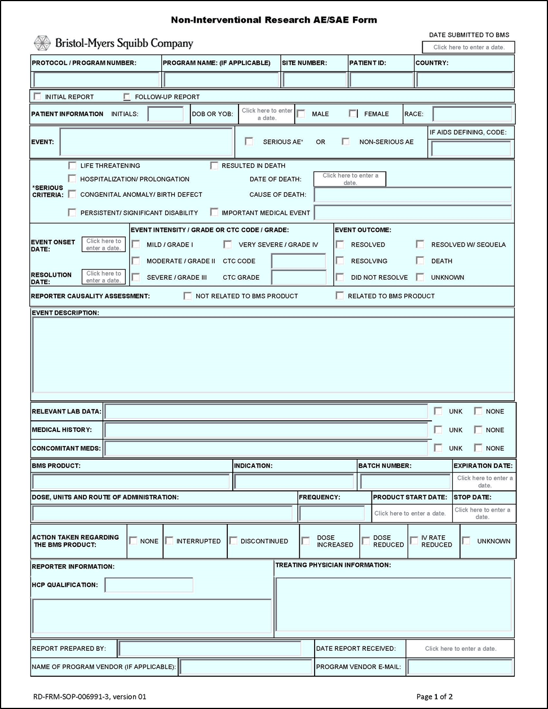

AE/SAE Form Instructions – NIR Studies
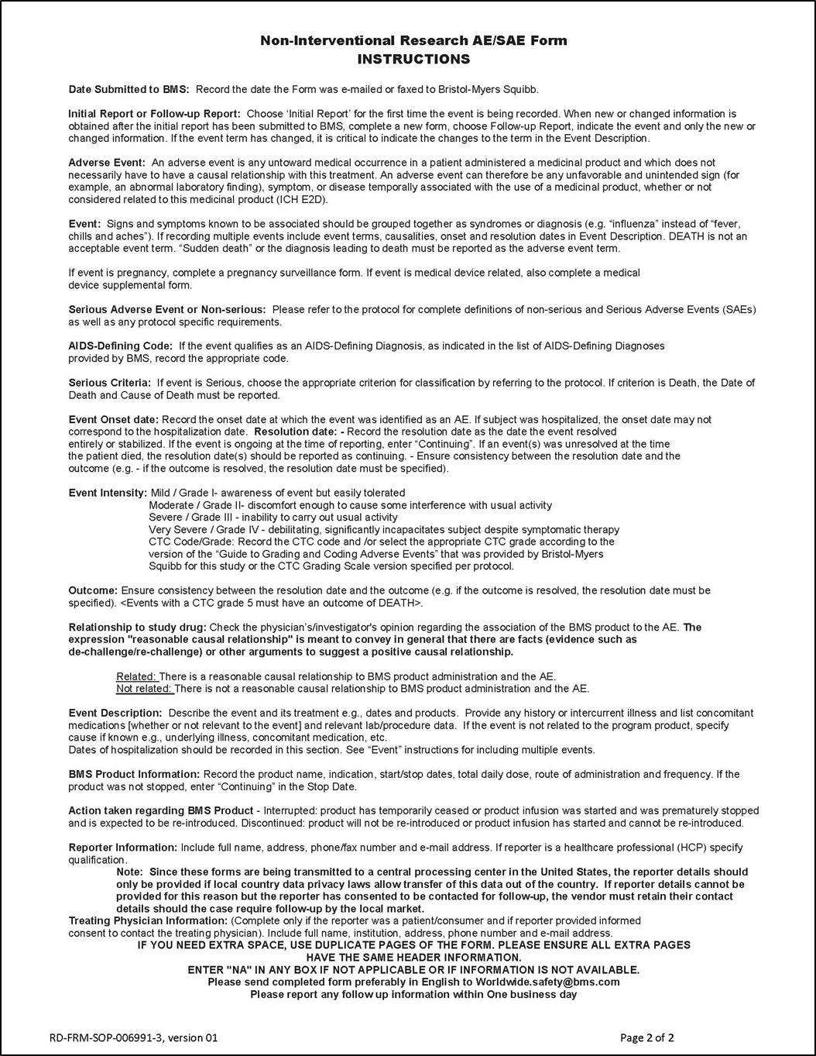

Pregnancy Forms

Master Template document history

Version | Date | Author | Description
1.0 | 27-June-2013 | BMS GPV&E | V1 Master Template
2.0 | 01-Feb-2017 | BMS GPV&E | V2 Master Template
3.0 | 30-Sept-2018 | BMS GPV&E | V3 Master Template: Removal of Adverse event definitions. Process change to reconciliation process.
4.0 | 12-August-2019 | BMS GPV&E | V4 Master Template: BMS SOPs updated (Section 2.3.1). Process change to reconciliation procedure (Section 2.6.9.2).
5.0 | 12-December-2019 | BMS GP&E | V5 Master Template: Collection requirement of Unexpected Benefit for cases occurring in France added. (Section 2.6.7)

list of abbreviations
AE | Adverse Event
BMS | Bristol-Myers Squibb
BMS GPV&E | Bristol-Myers Squibb Global Pharmacovigilance and Epidemiology
EC | Ethics Committee
IMP | Investigational Medicinal Product
IRB | Institutional Review Board
SAE | Serious Adverse Event
SAE MP | Serious Adverse Event Management Plan
SOP | Standard Operating Procedure
SUSAR | Suspected Unexpected Serious Adverse Reaction

